Multisearch command
Multisearch is a generating command that runs multiple streaming searches at the same time. It requires at least two searches and should only contain purely streaming operations such as eval, fields, or rex within each search.
One major benefit of the multisearch command is that it runs multiple searches simultaneously rather than sequentially as with the append command. This could save you some runtime especially when running more complex searches that include multiple calculations and/or inline extractions per data source. Results from the multisearch command are interleaved, not added to the end of the results as with the append command.
Learn more about using the multisearch command in Splunk Docs for Splunk Enterprise or Splunk Cloud Platform.

Syntax for the multisearch command
| multisearch [<search1>] [<search2>] [<search3>] ...
Since multisearch is a generating command, it must be the first command in your SPL. It is important to note that the searches specified in square brackets above are not actual subsearches. They are full searches that produce separate sets of data that will be merged to get the expected results. A subsearch is a search within a primary or outer search. When a search contains a subsearch, the Splunk platform processes the subsearch first as a distinct search job and then runs the primary search.

Pros
- Merges data from multiple data sources
- Runs searches simultaneously, thereby saving runtime with complex searches
- There is no limit to the number of result rows it can produce
- Results from the multisearch command are interleaved, allowing for a more organized view

Cons
- Requires that the searches are entirely distributable or streamable
- Can be resource-intensive due to multiple searches running concurrently. This needs to be taken into consideration since it can cause search heads to crash
In the example shown below, the multisearch command is used to combine the action field from the web_logs index and queue field from the tutorial_games index using the eval command to view the sequence of events and identify any roadblocks in customer purchases. The results are interleaved using the _time field.
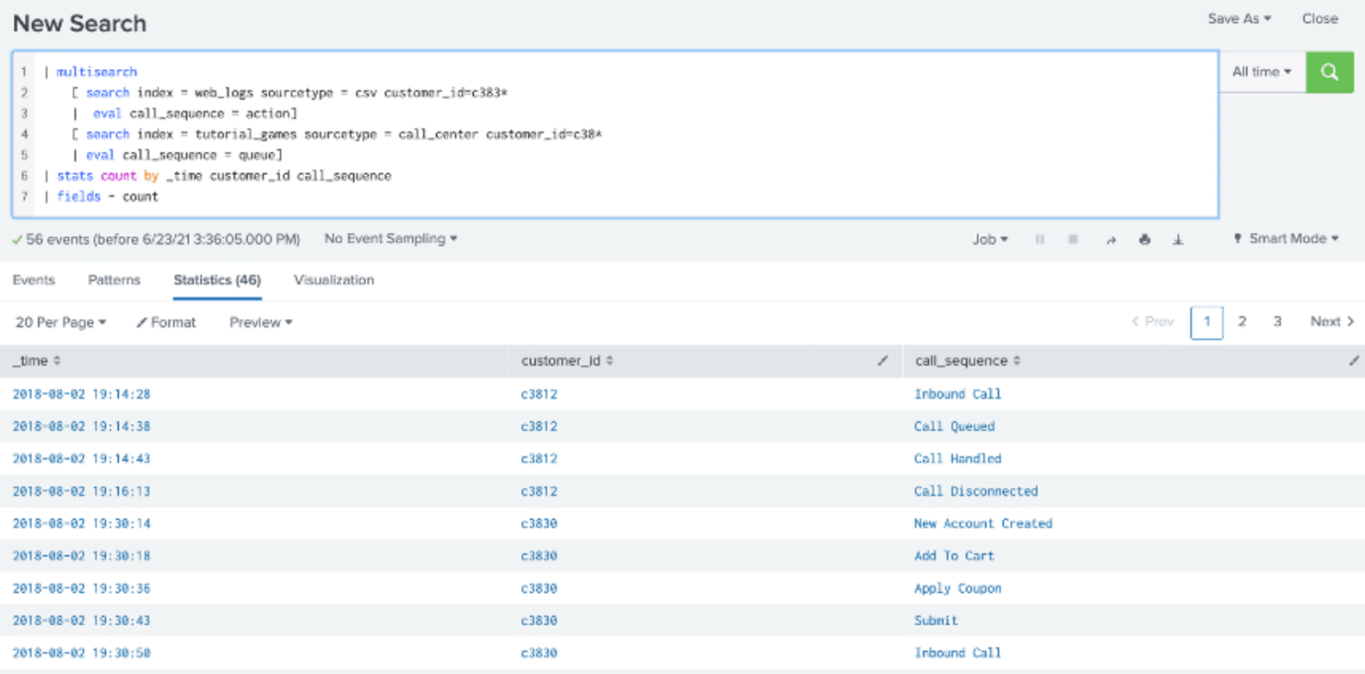
Baselining IP’s on a Domain and Monitoring for new IP’s

- Baseline Creation:
  - Run a search to extract all IP addresses from DNS data for your internal domain.
  - Store these IP addresses in a lookup table or an index, marking them as the baseline.
- Monitoring New IP Addresses:
  - Set up a regular scheduled search to retrieve new DNS data for the internal domain.
  - Compare the new DNS data against the baseline data to identify new IP addresses.
  - Display the new IP addresses in the search results.
Here's a more detailed breakdown of the steps:
Step 1: Baseline Creation
Run a search to extract all IP addresses from DNS data for your internal domain and store them in a lookup table or index. This will serve as your baseline data.
**save this search as a report and then use the outputlookup command**
splunk
index=your_dns_index sourcetype=your_dns_sourcetype domain=your_internal_domain
| rex field=answers{} "(?<answersIPv4>\b(?:\d{1,3}\.){3}\d{1,3}\b)"
| table answersIPv4
| dedup answersIPv4
| outputlookup internal_domain_baseline_lookup
Replace your_dns_index, your_dns_sourcetype, and your_internal_domain with your actual index, sourcetype, and internal domain.
Step 2: Monitoring New IP Addresses
Set up a scheduled search to retrieve new DNS data for the internal domain and compare it against the baseline data. Display the new IP addresses in the search results.
splunk
index=your_dns_index sourcetype=your_dns_sourcetype domain=your_internal_domain
| rex field=answers{} "(?<answersIPv4>\b(?:\d{1,3}\.){3}\d{1,3}\b)"
| table answersIPv4
| dedup answersIPv4
| inputlookup internal_domain_baseline_lookup
| eval isNew=if(isnull(answersIPv4), 0, 1)
| where isNew=1
This search retrieves new DNS data for the internal domain, extracts the IP addresses, and compares them against the baseline lookup table. It adds a field isNew to indicate whether an IP address is new or not. Finally, it filters the results to show only the new IP addresses.
Using Lookups in Splunk
First the before using outputlookup command, the data should either already be in splunk as a report or a physical csv needs to be ingested. One that is done use the
outputlookup <lookup.csv>
• Create a Lookup Definition:
- Prepare data set 2 to serve as a lookup. Create a CSV file that contains the columns IP and VLAN. This CSV file will act as the lookup file.
• Upload the Lookup CSV:
- Upload the lookup CSV file to a location accessible by Splunk, such as the $SPLUNK_HOME/etc/apps/your_app/lookups directory.
• Define the Lookup:
- Define a lookup using Splunk's web interface or by creating a .csv file in the lookups directory. The lookup definition will specify the columns to match on and the columns to retrieve from the lookup data (in this case, IP and VLAN).
• Apply the Lookup:
- Use the lookup command in your search to apply the lookup to data set 1 and add the VLAN information.
spl
- | inputlookup dataset2_lookup.csv
- | lookup dataset2_lookup IP OUTPUT VLAN
- | table IP Domain VLAN
- This search will look up the VLAN information from data set 2 using the IP field as the common key and add the VLAN information to data set 1.
- Display the Results:
  - The table command is used to display the resulting fields (IP, Domain, VLAN) in the search results.
Remember to replace dataset2_lookup.csv with the actual name of your lookup file. Additionally, adjust the column names and paths according to your data and environment.
By following these steps, you'll be able to enrich data set 1 with VLAN information from data set 2 using lookups in Splunk.

